Advancing on a hit
When a runner advances on a hit, it is recorded by writing the batting order number of the batter who was awarded a base hit in the square corresponding to the base reached. Thus, (example 26) if first and second bases are occupied and the third batter in the batting order hits a single, allowing the runners to reach second and third respectively, the runners’ arrival at second and third bases is recorded with a number three in the squares corresponding to those bases.
WBSC |  | Traduction dans l’outil de scorage |  | Outil
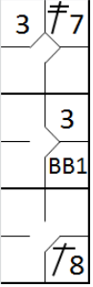 |  | /* Le premier batteur frappe un double dans le champ gauche */  action { batter -> 2B7 }  /* Le batteur suivant gagne la première base sur un 'base on ball' */  action { batter -> BB }  /* Le batteur suivant frappe un simple dans le champ centre, les deux coureurs avance */  action { batter -> 1B8, runner1 -> +, runner2 -> + } |  | 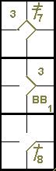

Example 27: With a runner on first base, the batter (second in the batting order) hits a single, allowing the runner to reach third base. This is recorded with a number two in the corresponding square.
WBSC |  | Traduction dans l’outil de scorage |  | Outil
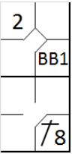 |  | /* Le premier batteur gagne la première base sur un 'base on ball' */  action { batter -> BB }  /* Le batteur suivant frappe un hit en champ centre, le coureur gagne deux bases */  action { batter -> 1B8, runner1 -> ++ } |  | 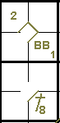

Example 28: With a runner on first base, the batter (eighth in the batting order) hits a double, enabling the runner to reach home base. The number eight is therefore noted in the home base square.
WBSC |  | Traduction dans l’outil de scorage |  | Outil
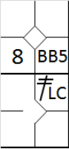 |  | /* Le premier batteur gagne la première base sur un 'base on ball' */  action { batter -> BB }  /* Le batteur suivant frappe un double en champ gauche, le coureur gagne trois bases et marque le point*/  action { batter -> 2BLC, runner1 -> +++ } |  | 